**Sequence Diagram:**

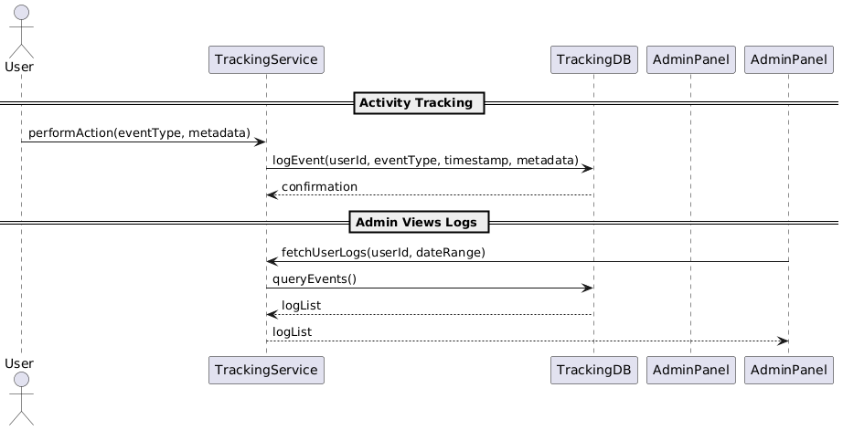

**State Diagram**



**Class Diagram**

**ERD**

**Functional Requirements**

1. System tracks user actions like login, logout, post creation, comment, likes, and shares.
2. Admins can view detailed activity logs for each user.
3. Actions should be timestamped and categorized.
4. Analytics engine uses tracking data to generate reports.
5. Users may request their activity history as a downloadable report.
6. The system should track IP address, device type, and location metadata (where applicable).
7. Tracking events must be stored efficiently in a time-series format.

**Non-Functional Requirements**

1. Events must be logged within 500ms of the action.
2. Tracking data must be encrypted and privacy-compliant.
3. The system should scale to handle 10,000+ events per day.
4. Logs must be retained for a minimum of 1 year.
5. Users should only access their own logs unless authorized.